**Documentation of distributed the medlowrecommendation.sh on DEV**

Step 1: Login to tfh001uc

Scp the file to tfh013uc

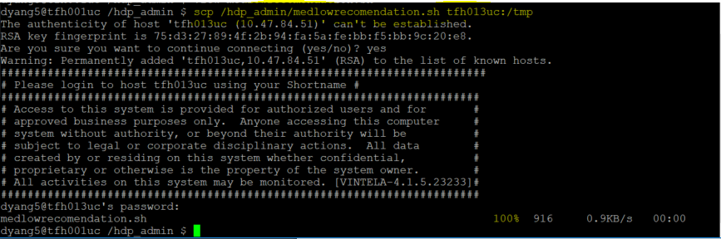

Step 2: Login to tfh013uc

Verify the /tmp to see the medlowrecommendation.sh.

Move the medlowrecommendation.sh to /hdp_admin

sudo mv medlowrecomendation.sh /hdp_admin

**medlowrecomendation.sh**

#!/bin/bash

read -p " Are you sure, you want to run this script(y/n)?" -n 1 -r

echo

if [[ $REPLY =~ [Yy]$ ]];

then

echo '------Start to run execute improvement of memory in dirty background -----------' > improvememory.txt

sudo sysctl -w vm.dirty_background_ratio=20 >> improvememory.txt

echo

echo '-------The dirty background ratio: ----------' >> improvememory.txt

sudo sysctl vm.dirty_background_ratio >> improvememory.txt

echo

echo '------- Start to run execute improvement of memory in dirty ratio --------------' >> improvememory.txt

sudo sysctl -w vm.dirty_ratio=50 >> improvememory.txt

echo '---------The Current Status of dirt ratio: -----------' >> improvememory.txt

sudo sysctl vm.dirty_ratio >> improvememory.txt

echo '-----------------------------------------------' >> improvememory.txt

fi

exit 0

Step 3: Repeat the steps to distribute the file to all the node tfh013uc – tfh020uc

scp /hdp_admin/medlowrecomendation.sh tfh014uc:/tmp

sudo mv medlowrecomendation.sh /hdp_admin/

**Documentation of distributing the osvirtualmemory on DEV**

**#/etc/init.d/osvirtualmemory**

#!/bin/bash

### BEGIN INIT INFO

# Provides: osvirtualmemory-disable-thp

# Required-Start: $local_fs

# chkconfig: - 99 10  
# Required-Stop:  
# X-Start-Before: couchbase-server  
# Default-Start: 2 3 4 5  
# Default-Stop: 0 1 6  
# Short-Description: Disable THP  
# Description: Improve virtual memory usage  
### END INIT INFO

case $1 in

start)

sudo sysctl -w vm.dirty_background_ratio=20

sudo sysctl -w vm.dirty_ratio=50

;;

esac

exit 0

**Configurations for osvirtualmemory**

**Step 1:**

#Create the file osvirtualmemory

sudo nano /etc/init.d/osvirtualmemory

#change mod the file to executable

sudo chmod 755 /etc/init.d/osvirtualmemory

#run the command set the change to start at boot

sudo chkconfig osvirtualmemory on

#check if your file in on the list osvirtualmemory (0:off, 1:off, 2:on, 3:on, 4:on, 5:on, 6:off)

sudo chkconfig

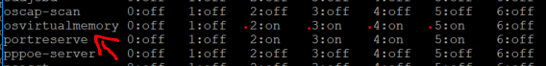

**Step 2:**

Repeat these same steps in Step 1 until completion of applying the file “osvirtualmemory” through tfh013uc.travp.net to tfh028uc.travp.net AND tfh053uc.travp.net to the /etc/init.d